Shenzhen Genstar Technology Co., Ltd.

Model: Z2 Series

specification

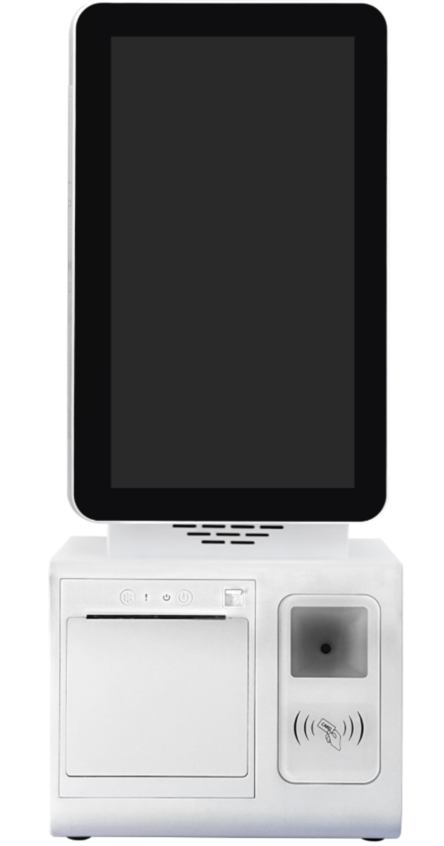
Photo Statement: The photo was taken of products from a specific batch manufactured by our company. Due to ongoing maintenance, the actual shipped products may differ from those shown in the photo.

version number | date of issue
V1.4 | 2026/8/19

Thank you for choosing our products. Please read this manual carefully before use.

Product Usage Precautions

- This equipment must be installed, disassembled, and maintained by technically trained personnel.
- Before powering on, carefully verify that the electrical parameters of the power supply equipment match those specified on the rear casing label of this product; otherwise, do not power on.
- Ensure that products with a supply voltage higher than the safe voltage are installed or placed in locations inaccessible to children or where adequate protective measures are in place.
- Unplug the power cord and store it in a safe, designated location during thunderstorms or lightning, when the interior is unoccupied, or after prolonged disuse.
- Check and ensure that the ground wire of the AC power cord is properly connected, while protecting the power cord from physical or mechanical damage.
- During cleaning, ensure the entire unit is powered off and unplug the power socket.
- During installation, avoid harsh conditions such as damp environments, direct sunlight, high-temperature sources, heavy cooking fumes, or strong wind and sand.
- Do not place the antenna inside a metal enclosure or similar shielding equipment to prevent network disconnections or instability.
- Do not place heavy objects on the device to avoid excessive pressure, which may damage the equipment and prevent it from functioning properly.
- Avoid using in vehicles or environments with significant vibrations to prevent poor interface contact.
- Private disassembly and repair without permission is strictly prohibited.

Product Presentation
GENSTAR Z3 is a high-performance smart self-service cash register terminal specifically designed for small retail scenarios such as supermarkets and convenience stores. It is deeply adapted to unattended operation needs and integrates core capabilities such as multiple payment methods, intelligent verification, receipt printing, and advertising operations. It supports flexible deployment in various forms, including single/dual screens, portrait/landscape, providing a stable, efficient, and scalable integrated terminal solution for the digital upgrade of stores.
The product can be equipped with mature and stable Android/Windows versions: Android 11/12/13/14, Windows 10/11, meeting the smooth operation requirements of 7×24 hours unattended operation. It adopts a G+G ten-point capacitive touch screen, featuring sensitive operation and rapid response, suitable for high-frequency self-service scenarios; the built-in speaker supports voice broadcast, optimizing the user interaction experience.
The terminal fully supports face recognition payment, one-dimensional/two-dimensional scanning payment, and seamlessly adapts to mainstream payment methods such as WeChat, providing high cashier efficiency and convenient experience. It can be equipped with 58/80MM thermal printers, binocular/3D structured light cameras, 4G communication modules, IC/ID card readers, ID card recognition, temperature sensors, and other functions as needed, expanding multi-scenario application capabilities such as government verification and self-service. It offers 10.1-inch/11.6-inch single-screen and dual-screen versions to accommodate different store layouts. It comes standard with a rich set of interfaces including DC-IN, MINI HDMI, USB-A, RJ45 network ports, and RJ11 cash drawer ports, supporting independent cashiering and deep system integration, seamlessly adapting to various retail management systems and reducing deployment costs. The product supports customized development, provides comprehensive technical support and after-sales guarantees, and meets the full project implementation needs.

Reference standard:
GB 4943.1-2022 "Safety Requirements for Audio and Video, Information Technology, and Communication Technology Equipment";
GB/T 9254.1-2021 "Information technology equipment, multimedia equipment and receivers - Electromagnetic compatibility - Part 1: Emission requirements";

Certification:
3C certification (China)
FCC (United States), CE (European Union), RoHS (European Union)

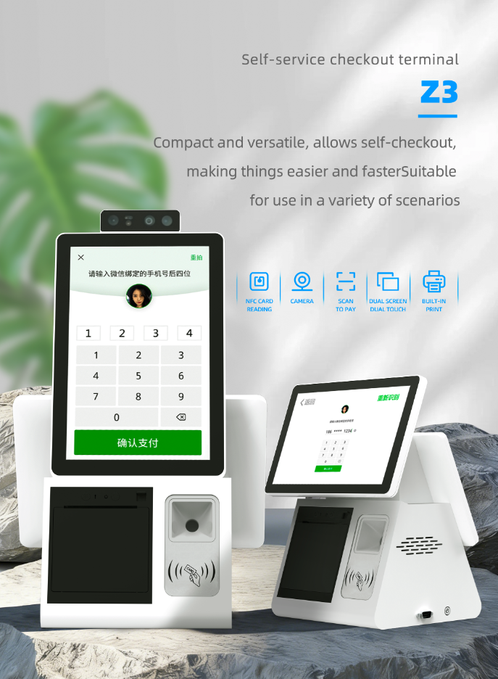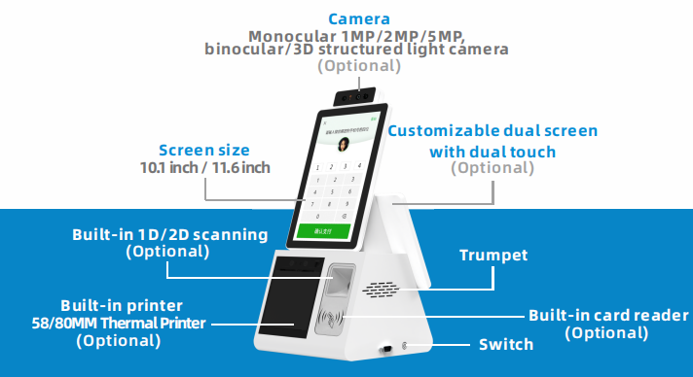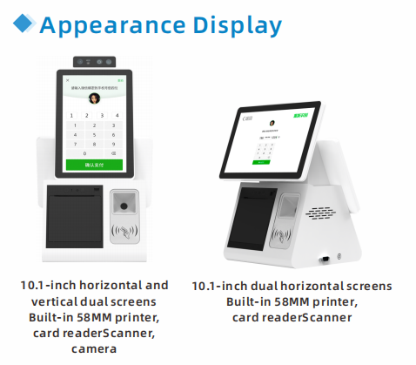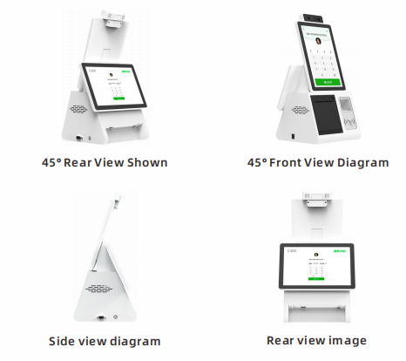

Product Core Parameters
Android system | RK3568 | RK3576 | RK3588
CPU | Rockchip RK3568 quad-core 64-bit processor with Cortex-A55 architecture, featuring a maximum clock speed of 2.0GHz | Rockchip RK3576 quad-core Cortex-A72 + quad-core Cortex-A53, with a maximum frequency of 2.2GHz | The Rockchip RK3588S is an octa-core 64-bit processor with a maximum clock speed of 2.4GHz, featuring a quad-core Cortex-A76 (large core) and quad-core Cortex-A55 (small core) architecture.
GPU | ARM G52 2EE  Supports OpenGLES 1.1/2.0/3.2, OpenCL 2.0, and Vulkan 1.1  Embedded high-performance 2D acceleration hardware | ARM G52 MC3  Supports OpenGLES 1.1/2.0/3.2, OpenCL 2.0, and Vulkan 1.1.  Embedded high-performance 2D acceleration hardware | ARM G610 GPU MC4 quad-core GPU  Supports OpenGL ES3.2, OpenVG1.1, and OpenCL2.2, with 450 GFLOFS  Embedded high-performance 2D acceleration hardware
NPU | Equipped with a built-in neural network processor (NPU) delivering 0.8TOPS@INT8 performance, it supports AI development tools including Caffe/Mxnet/TensorFlow/TF Lite/ONNX/Darknet for model deployment. Features rapid model conversion capabilities. | Equipped with a built-in neural network processor (NPU) delivering 6.0TOPS@INT8 performance, it supports models including Caffe, Mxnet, TensorFlow, PyTorch, TF Lite, ONNX, and Darknet, providing comprehensive AI development tools with rapid model conversion capabilities. | Equipped with a built-in neural network processor (NPU) for powerful AI computing: Supports IN4/IN8/INT16/FP16 operations with up to 6.0 TOPS performance, enabling direct loading of models like Caffe/Mxnet/TensorFlow/TF Lite/ONNX/Darknet. Provides AI development tools including rapid model conversion capabilities.
Operating System | Android 11 | Android 14 | Android 12
RAM | LPDDR4 2GB (4G/8G optional) | LPDDR4 4GB (8G/16G optional) | LPDDR4 4GB (8G/16G/32G optional)
ROM | eMMC 16GB (available in 32G,64G,128G, or 256G options) | eMMC 32GB (available in 64G,128G,256G, or 512G options) | eMMC 32GB (64G/128G/256G optional) TF Card expansion (optional)
Ethernet | Supports Ethernet 10/100 | Supports Ethernet 10/100/1000 speeds | Supports Ethernet 10/100/1000 speeds
WiFi | Supports 2.4GHz and Wi-Fi 802.11b/g/n/ac protocols. (Optional 5GHz dual-band WiFi) | Supports 2.4GHz and WiFi6 802.11b/g/n/ax protocols (5GHz dual-band WiFi optional) | Supports 2.4G WiFi and Wi-Fi 802.11b/g/n protocols. (Optional 5GHz dual-band WiFi)
Bluetooth | Supports Bluetooth function, V2.1+EDR (optional 3.0/3.0+HS/4.1/BLE) | Supports Bluetooth function, V2.1+EDR (optional 3.0/3.0+HS/4.1/BLE) | Supports Bluetooth function, V2.1+EDR (optional 3.0/3.0+HS/4.1/BLE)

Screen |  |  | remarks
LCD type | TFT | TFT
LCD size | 10.1 inch | 11.6 inches
Active Area(W×H) | 135.36 x 216.58 mm | 256.125 x 144 mm
Number of Dots | 800*RGB*1280 | 1366*768
Brightness | 300 Cd/m2 | 220 Cd/m2
Viewing Angle(H)θ3 | 85 degrees | 45 degrees
Viewing Angle(H)θ9 | 85 degrees | 45 degrees
Viewing Angle(V)θ12 | 85 degrees | 20 degrees
Viewing Angle(V)θ6 | 85 degrees | 40 degrees
Contrast Ratio | 800~1000 | 500
Response Time | 35 ms | 12 ms
Colour Gamut | NTSC 60%(Typ) | 45%

Touchscreen/Glass |  | remarks
structure | G+G
Tempered glass thickness | 1.1 mm
Sensor thickness | 0.7 mm
Cover plate color | black
surface hardness | >6H
Number of contacts | 10
Touch area | Φ≥9
input mode | Finger or conductive pen
Total light transmittance | ≥86%
fog level | ≤5%

Printer |  | remarks
Print mode | temperature-sensitive
Print Speed | MAX:200mm/s
Resolution | 203dpi
Effective print area | 72mm
Paper type | Continuous thermal paper, die-cut label paper, black label paper
Paper width | 43-80mm (adjustable)
Max Paper Rolldiameter | max：80mm
Paper Thickness | 0.053-0.09mm(receipt)/0.10-0.15mm(label)
Print Life | ≥100 KM
Cutter | Auto cutter, full cut and half cut (via command)
Cutter Life | ≥1,000,000 occurrences
Character Set | ESC/POS (bill), CPCL, TSPL, JPL (label)
Barcode | UPC-A,UPC-E,EAN8,EAN13,code39,ITF,CODEBAR,CODE128,CODE93
QR code | QR code,PDF417

Scanner |  | remarks
imaging sensor | CMOS
resolution ratio | 300,000 pixels, 640*480
Recognition accuracy | ≥10 mil
recognition distance | 0~100 mm
readable encoding system | Two-dimensional formats: PDF417, QR Code, Data Matrix, Hanxin Code, GM Code, Aztec, MicroQR, MicroPDF417, etc.
readable encoding system | One-dimensional: Code 128, EAN-13, EAN-8, Code39, GS1, UPC-A, UPC-C, Code11, Code93, Codebar, China Post, etc.

IC/ID card reader |  | remarks
Supports cards | Reading 125kHz and 13.56MHz cards
communication interface | USB
Card reading distance | 20~50mm

Loudspeaker |  | remarks
impedance | 4Ω±15%
power rating | 3W
maximum power | 4W

Product operating environment parameters
Storage temperature and humidity | -20～70℃，10～85 %RH
Working temperature and humidity | -20～50℃，10～80 %RH
Electrostatic Discharge Immunity (ESD) | Contact voltage: ±6 kV; air voltage: ±8 kV
Power Input | DC12V
Protection rating | IP33

Product appearance and interfaces:
